

**SOFTWARE ENGINEERING ASSIGNMENT**

**MODULE: - 1**

**SE – Overview of IT Industry**

1. **What is Software? What is Software Engineering?**
2. **Explain types of software.**
3. **What is SDLC? Explain each phase of SDLC.**
4. **What is DFD? Create a DFD diagram on Flipkart.**
5. **What is Flow chart? Create a flowchart to make addition of two numbers.**
6. **What is Use Case diagram? Create a use-case on bill payment on Paytm.**
7. **What is Software? What is Software Engineering?**

* **Software: -** set of instructions executed by any kind of tool.
* **Software Engineering: -** use of engineering principles for developing software.

1. **Explain types of software.**

* **There are two types of software: -**

1. System Software
2. Application Software

* **Now we will briefly describe each type: -**

1. **System Software: -**

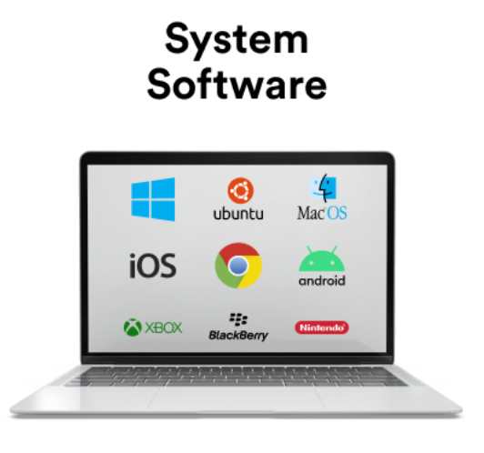

**[ Figure: - 1.1 System Software]**

* + System Software is directly operating the computer hardware and provide the basic functionality to the user as well as to the other software to operate smoothly.
  + In other words, system software basically controls a computer’s internal functionality and also controls hardware devices such as monitors, printers and storage devices etc.
  + It is like an interface between hardware and user applications, it helps them to communicate with each other because hardware understands machine language (i.e. 1 and 0).
  + E.g. calculator, notepad, clock.

1. **Application Software: -**

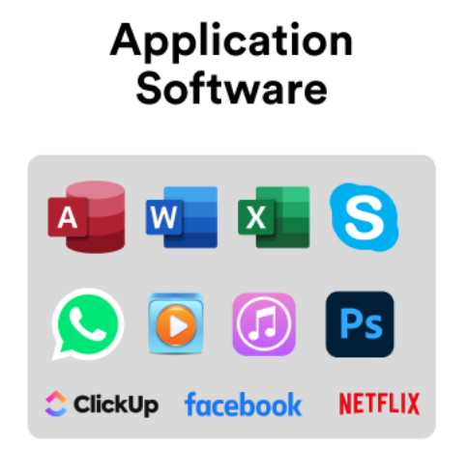

**[Figure: - 1.2 Application Software]**

* + Application software is designed to perform a specific task for end-users. It is product or a program that is designed only to fulfill end-users’ requirements. It includes word processors, spreadsheets, database management, payroll programs.
  + Software that performs special functions or provides functions that are more than basic operation of the computer is known as application software.
  + E.g. WhatsApp, Instagram, LinkedIn, Twitter, Zoom.

**3. What is SDLC? Explain each phase of SDLC.**

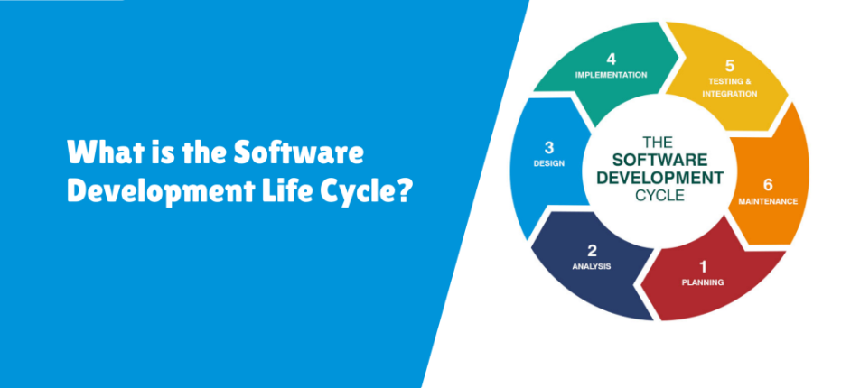

**[Figure: - 3.1 SDLC]**

* **SDLC: -** Software Development Life Cycle.
* A step by step methods to develop any product/software with high quality, lowest cost with shortest possible time.
* **There are 6 phases of SDLC: -**

1. Planning / Requirement Gathering
2. Analysis
3. Designing
4. Implementation / Coding / Building
5. Testing
6. Maintenance
7. **Planning / Requirement Gathering: -**

* Planning for the quality assurance requirements and identifications of the risks associated with the projects is also done at this stage.
* Requirement analysis is the most and necessary stage in SDLC.
* Business analyst and project organizer set up a meeting with the client to gather all data like what the customer wants to build, who will be the end user, what is the objective of the product.
* Before a creating a product, a core understanding or knowledge of the product is very necessary.
* For example, A client to have an application which concerns money transactions. In this method, the requirement has to be precise like what kind of operations will be done, how it will be done, in which currency it will be done.

1. **Analysis: -**

* The second step of SDLC is gathering maximum information from the client requirements for the product.
* Discuss each detail and specification of the product with the customer.
* The development team will be analyzing the requirements keeping the design and code of the software in mind.
* Further, investigating the validity and possibility of incorporating these requirements into the software system.
* The main goal of this stage is that everyone understands even minute detail of the requirement.
* e.g. Hardware, operating systems, programming and security are to name the few requirements.

1. **Designing: -**

* When the requirements are arranged out programming draftsmen and engineers start carrying out programming particulars into a plan.
* This stage builds up designs that will be utilized for application engineering and programming improvement. Partners survey the plan and give criticism. Create system architecture, data models and database designs.
* e.g. design documents, system architecture diagram, UI/UX design.

1. **Implementation / coding / building: -**

* Convert the design into executable code.
* Write and integrate code according to design specifications.
* Develop unit tests to verify code functionality.
* Perform code reviews and debugging.

1. **Testing: -**

* Verify that the software meets the requirements and is free of defects.
* Conduct various types of testing, including unit, integration, system and acceptance testing.
* Identify and fix defects or bugs.
* Validate that the software meets quality standards.
* E.g. test plan, test cases, test reports, bug reports.

1. **Maintenance: -**

* Ensure the software continues to function properly and meets evolving needs.
* Monitor the software for issues and performance.
* Address bugs and implement updates or enhancements.
* Provide ongoing support and troubleshooting.
* E.g. updated software, maintenance reports, user feedback.

**4. What is DFD? Create a DFD Diagram on Flipkart.**

* DFD is the abbreviation for Data Flow Diagram. The flow of data if a system or process is represented by DFD. It is also giving insight into the inputs and outputs of each entity and the process itself.
* **Create DFD Diagram on Flipkart Level – 0 DFD Diagram: -**

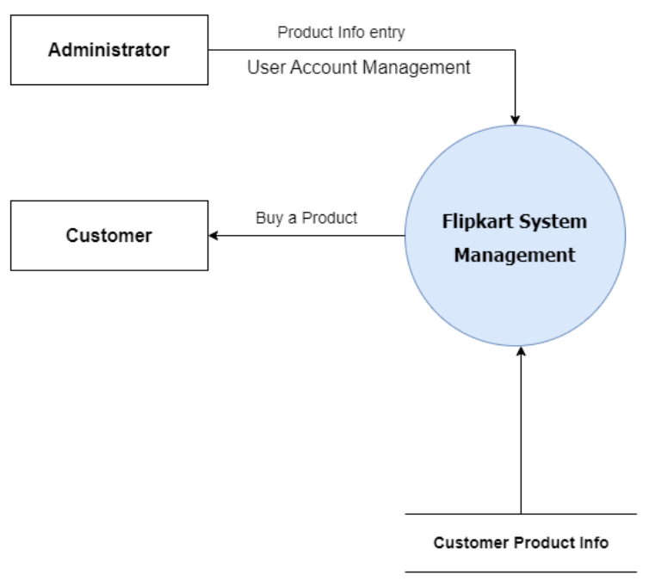

**[ Fig: - Level-0 DFD of Flipkart System Management]**

* **Description of Level-0 DFD Diagram of Flipkart System Management: -**

1. **Administrator: -**

* The Administrator interacts with the Flipkart System Management by entering product information and managing the user account.
* This interaction depicted by the arrows labeled “Product Info entry” and “User Account Management “pointing from the administrator to the Flipkart System Management.

1. **Customer: -**

* The customer interacts with the Flipkart System Management to buy a Products.
* This interaction is depicted by the arrow labeled “Buy a Product” pointing from the Flipkart System Management to the customer.

1. **Flipkart System Management: -**

* This central system manages product information and user accounts based on inputs from the administrator.
* The system is connected to the “Customer Product Info” repository, indicating that it stores or manages information about customer products.

1. **Customer Product Info: -**

* This is a repository or database that contains information about the products related to customers.

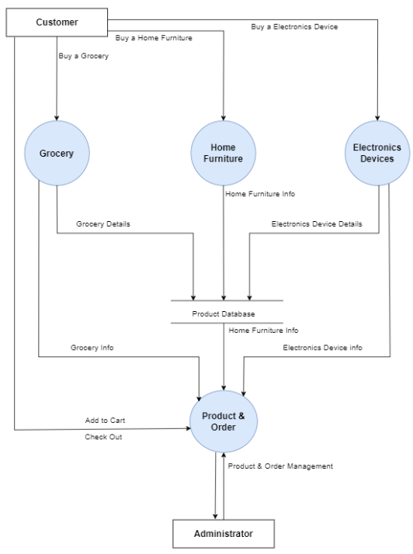

**[Fig: - Level-1 DFD of Flipkart System Management]**

* **Description of Level-1 DFD Diagram of Flipkart System Management: -**

1. **Customer: -**

* The customer can buy products from three different categories: Grocery, Home Furniture and Electronics Devices.
* **There are arrows showing interactions:**
  + - **“**Buy a Grocery**”** pointing from customer to grocery.
    - **“**Buy a Home Furniture**”** pointing form customer to Home Furniture.
    - **“**Buy an Electronics Devices**”** pointing from customer to Electronics Devices.

1. **Grocery: -**

* The Grocery section provides Grocery Details to the Product Database.
* There is an arrow labelled "Grocery Details" pointing from Grocery to Product Database.
* There is also an arrow labelled "Grocery Info" pointing from Product Database to Grocery, showing that it retrieves information about groceries.

1. **Home Furniture: -**

* The Home Furniture section provides Home Furniture Info to the Product Database.
* There is an arrow labelled "Home Furniture Info" pointing from Home Furniture to Product Database.
* There is also an arrow labelled "Home Furniture Info" pointing from Product Database to Home Furniture, showing that it retrieves information about home furniture.

1. **Electronics Devices: -**

* The Electronics Devices section provides Electronics Device Details to the Product Database.
* There is an arrow labelled "Electronics Device Details" pointing from Electronics Devices to Product Database.
* There is also an arrow labelled "Electronics Device Info" pointing from Product Database to Electronics Devices, showing that it retrieves information about electronics devices.

1. **Product & Order: -**

* The Product & Order section is at the center of the diagram and interacts with the Product Database, Customer, and Administrator.
* It receives Grocery Info, Home Furniture Info, and Electronics Device Info from the Product Database.
* There are arrows labelled "Add to Cart" and "Check Out" pointing from Customer to Product & Order, showing that customers can add items to their cart and check out.
* There is an arrow labelled "Product & Order Management" pointing from Product & Order to Administrator, showing that the administrator manages products and orders through this section.

1. **Administrator: -**

* The Administrator manages products and orders through the Product & Order section.
* There is an arrow labelled "Product & Order Management" pointing from Administrator to Product & Order.

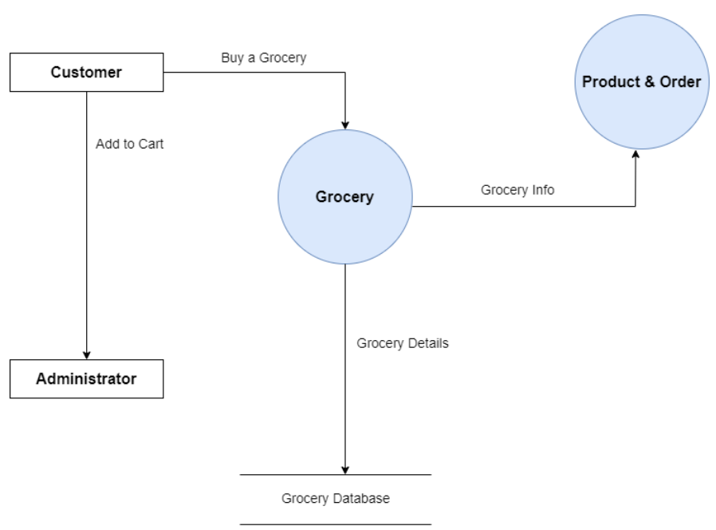

**[Fig: - Level-2 DFD of Grocery]**

* **Description of Level-2 DFD Diagram of Grocery: -**

1. **Customer: -**

* The Customer can perform actions related to buying groceries and adding items to their cart.
* **There are arrows showing interactions:**
* “Buy a Grocery" pointing from Customer to Grocery.
* "Add to Cart" pointing from Customer to Administrator.

1. **Grocery: -**

* The Grocery section is responsible for providing grocery details to the Grocery Database and grocery information to the Product & Order system.
* There is an arrow labelled "Grocery Details" pointing from Grocery to Grocery Database.
* There is also an arrow labelled "Grocery Info" pointing from Grocery to Product & Order.

1. **Product & Order: -**

* The Product & Order section interacts with the Grocery section to get grocery information.
* There is an arrow labelled "Grocery Info" pointing from Grocery to Product & Order.

1. **Administrator: -**

* The Administrator manages the system and interacts with the Customer and Grocery sections.
* There is an arrow labelled "Add to Cart" pointing from Customer to Administrator, indicating that the administrator is involved in the cart management process.

1. **Grocery Database: -**

* The Grocery Database stores detailed information about groceries.
* There is an arrow labelled "Grocery Details" pointing from Grocery to Grocery Database, indicating that grocery details are stored in the database.

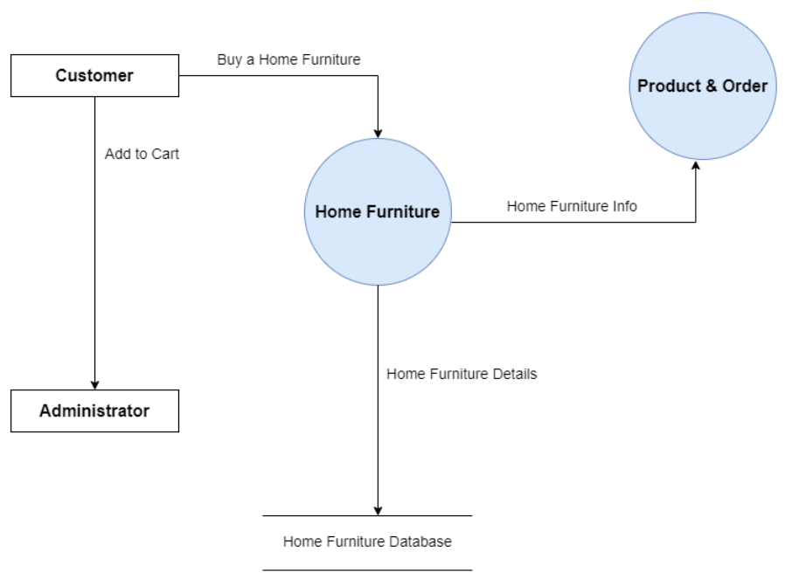

**[Fig: - Level-2 DFD of Home Furniture]**

* **Description of Level-2 DFD Diagram of Home Furniture: -**

1. **Customer: -**

* The customer initiates actions in the system.
* **Add to Cart**: The customer can add home furniture items to their cart.

1. **Home Furniture: -**

* This central entity handles various functions related to home furniture.
* **Buy a Home Furniture**: The customer can purchase home furniture.
* **Home Furniture Info**: This information flows from the Home Furniture system to the Product & Order system.
* **Home Furniture Details**: This information flows from the Home Furniture system to the Home Furniture Database.

1. **Product & Order: -**

* This entity manages the product and order information related to home furniture.
* It receives **Home Furniture Info** from the Home Furniture system.

1. **Administrator: -**

* The administrator manages and oversees the system.
* They can access the system and take necessary actions.

1. **Home Furniture Database: -**

* Stores detailed information about home furniture.
* Receives **Home Furniture Details** from the Home Furniture system.

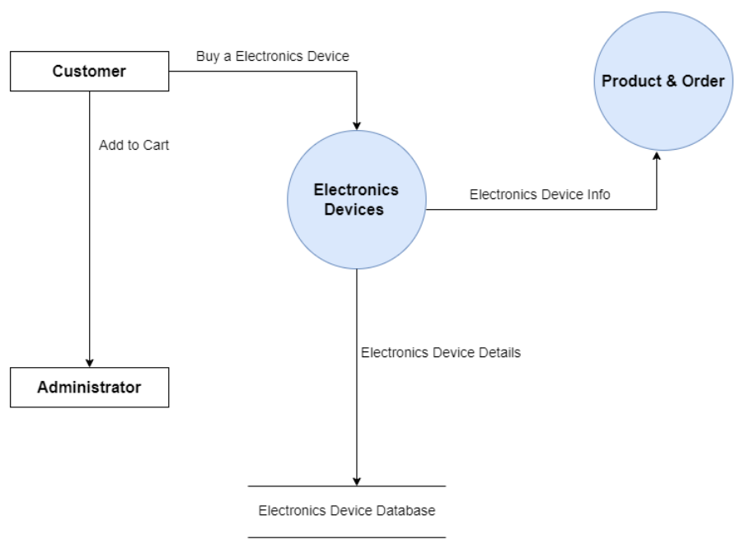

**[Fig: - Level-2 DFD of Electronics Device]**

* **Description of Level-2 DFD Diagram of Electronics Device: -**

1. **Customer: -**

* The customer initiates actions in the system.
* **Add to Cart**: The customer can add electronics devices to their cart.

1. **Electronics Device: -**

* This central entity handles various functions related to electronics devices.
* **Buy an Electronics Device**: The customer can purchase an electronics device.
* **Electronics Device Info**: This information flows from the Electronics Devices system to the Product & Order system.
* **Electronics Device Details**: This information flows from the Electronics Devices system to the Electronics Device Database.

1. **Product & Order: -**

* This entity manages the product and order information related to electronics devices.
* It receives **Electronics Device Info** from the Electronics Devices system.

1. **Administrator: -**

* The administrator manages and oversees the system.
* They can access the system and take necessary actions.

1. **Electronics Device Database: -**

* Stores detailed information about electronics devices.
* Receives **Electronics Device Details** from the Electronics Devices system.

**5. what is Flow Chart? Create a flowchart to make addition of two numbers.**

* A flowchart is a graphical representation of a process or a system that outlines the sequence of steps or actions needed to achieve a particular result. It uses various symbols to represent different types of actions, decisions, inputs, outputs, and other process elements. Flowcharts are widely used in business, engineering, education, and other fields to document, analyse, and communicate processes.

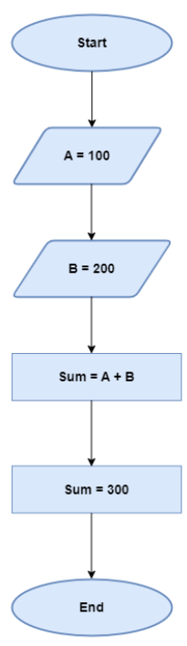

**[Fig: - Flowchart of Addition of Two Numbers]**

* **The flowchart provided outlines a simple process to calculate the sum of two numbers. Here’s step by step description: -**

1. **Start**: The process begins.
2. **A = 100**: The variable A is assigned the value 100.
3. **B = 200**: The variable B is assigned the value 200.
4. **Sum = A + B**: The sum of A and B is calculated and stored in the variable Sum.
5. **Sum = 300**: The result of the addition is 300.
6. **End**: The process ends.

**6. What is Use case Diagram? Create a use-case on bill payment on Paytm.**

* Usecase diagram represents How user interact with the system it serves.

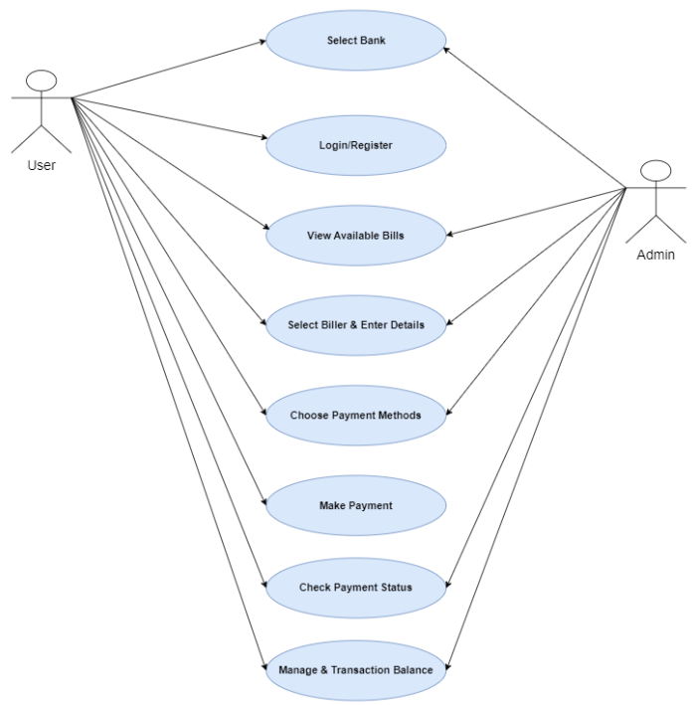

**[Fig: -Usecase Diagram for Bill Payment of Paytm]**